09/27/2025, Legacy (last week)

https://www.youtube.com/live/oYpNM6QuAQA?si=pzJg_yjW9PICLjaN

“Waging Peace: Bringing Hope to a World at War,” Phil EuBank, Lead Pastor

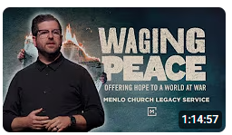

Phil EuBank, Lead Pastor

Introduction:

10:00/1:14:57

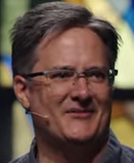 

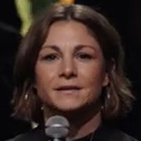

Rochelle, Pastor

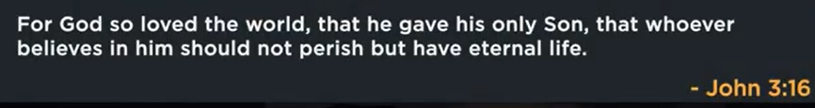

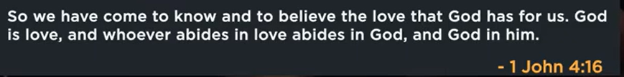

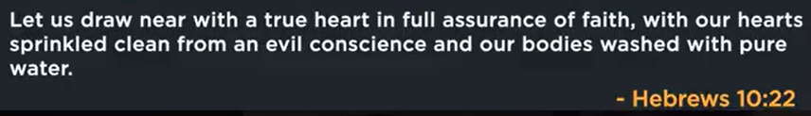

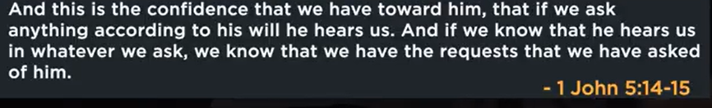

Tonight is the elder night.

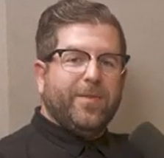

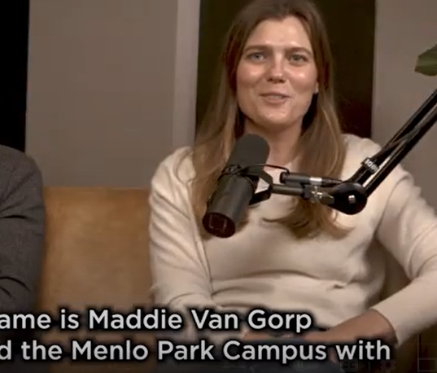

Maddie Van Gorp

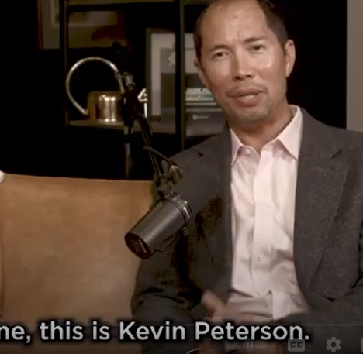

Kevin Peterson

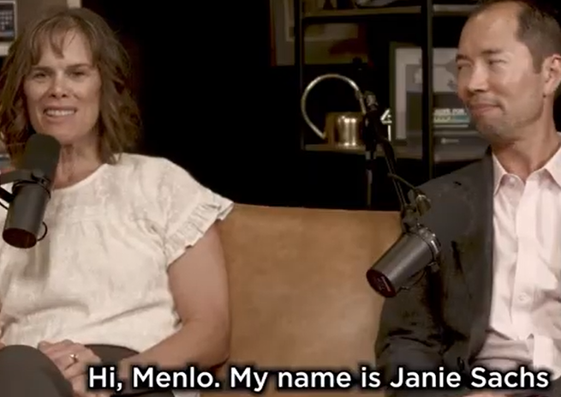

Janie Sachs

20:00/1:14:57

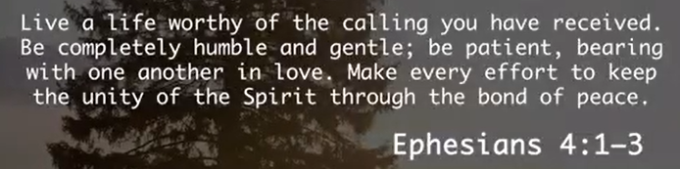

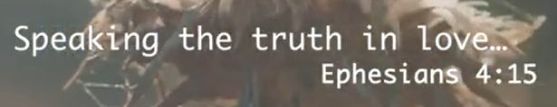

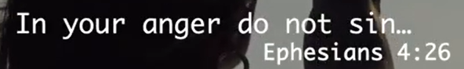

24:50/1:14:57

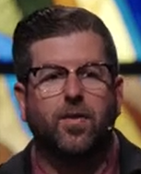 

We shift topic today.

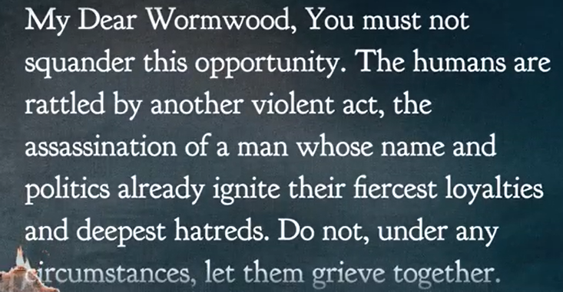

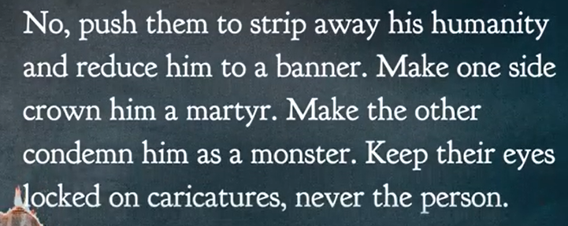

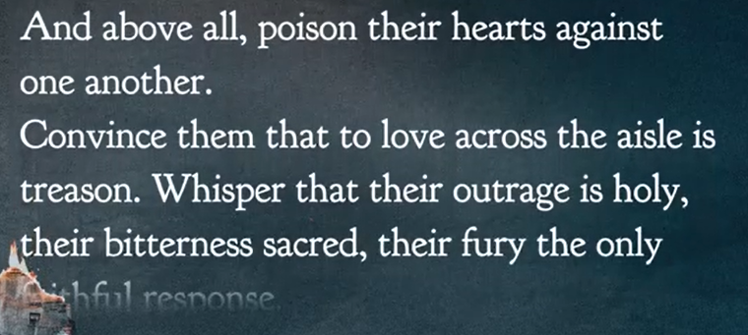

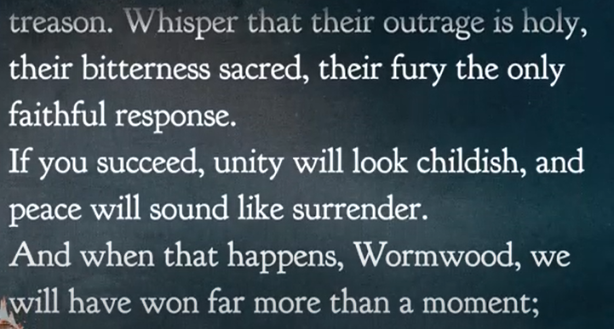

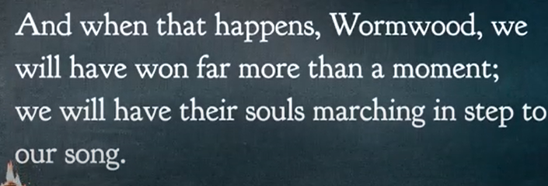

CS. Lewis

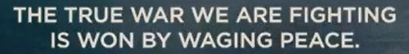



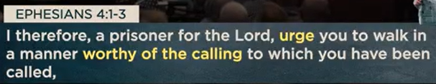

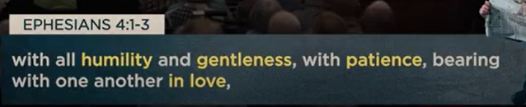

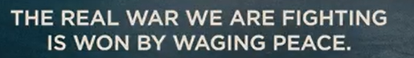



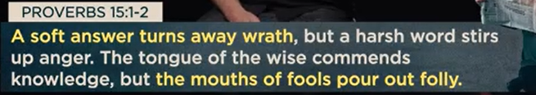

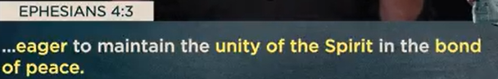

Because the politics can not satisfy our soul, we bring in the religion.

Hope does not mean ignore the reality.

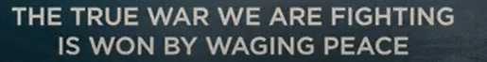



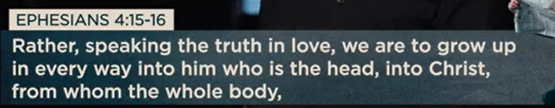

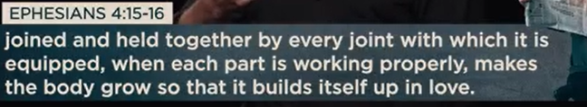

Jesus offers conviction and compassion.

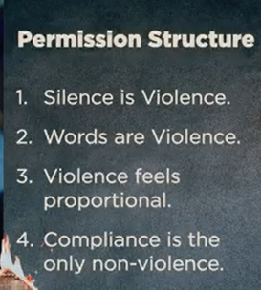

44:00/1:14:57



Real world we live are waging peace.

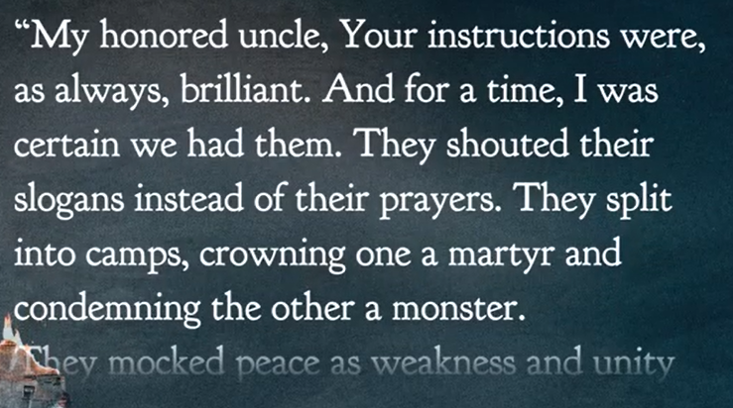

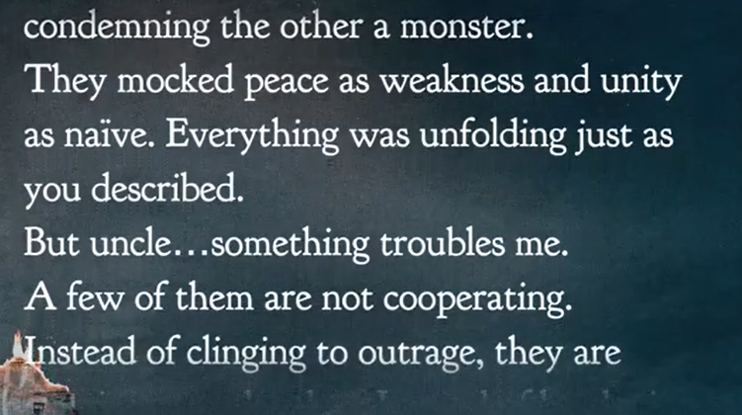

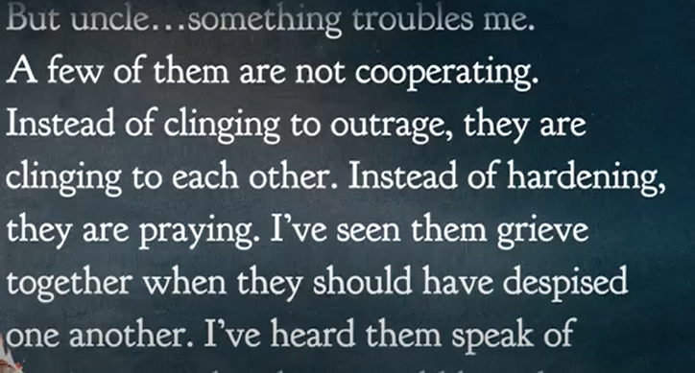

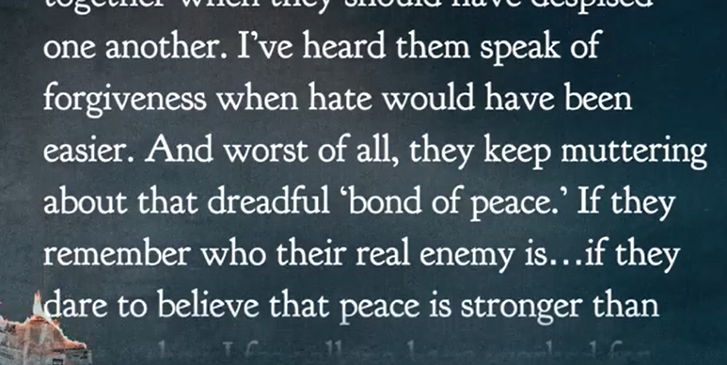

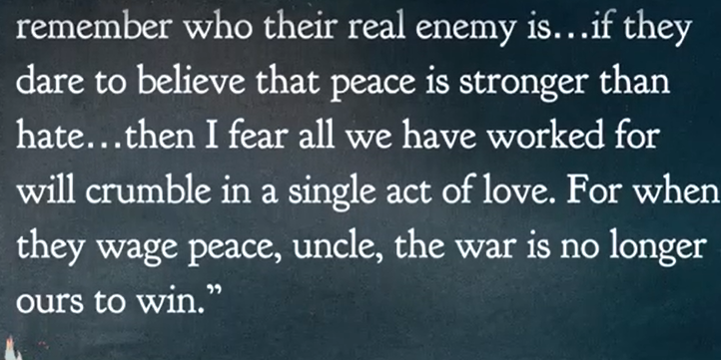

09/27/2025, Legacy (last week)

https://www.youtube.com/live/oYpNM6QuAQA?si=pzJg_yjW9PICLjaN

“Waging Peace: Bringing Hope to a World at War,” Phil EuBank, Lead Pastor

Summary: